Project planner

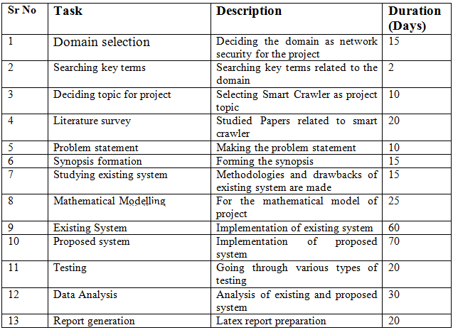

PERT chart/ Gantt chart

A work plan is a complete accounting of how a person or grouping proposes

going about accomplishing a specific task, approaching a project. Proposed work

plan generally includes an introduction or overview of a project or job, a breakdown

of how individual project-related tasks will be accomplished, a timeline for completion

and cost projections for implementation. The above figure 4.6 shows Gantt chart

of proposed plan work this chart explain the plan of work there are total eight task.

Task 1 is study IEEE paper in 30 days, task 2 signify design of algorithm, task 3 represent

design of GUI, task 4 represent preprocessing, task 5 signify the coding, task

6 represent Implementation it require 60 days to complete a work, task 7 correspond

to Integrating modules and testing and task 8 is documentation.

